First Saturday Budapest 2019 February GM-IM-Nadassy group

In the GM-section the INA IM PRIASMORO, Novendra reached his 3rd GM-norm.
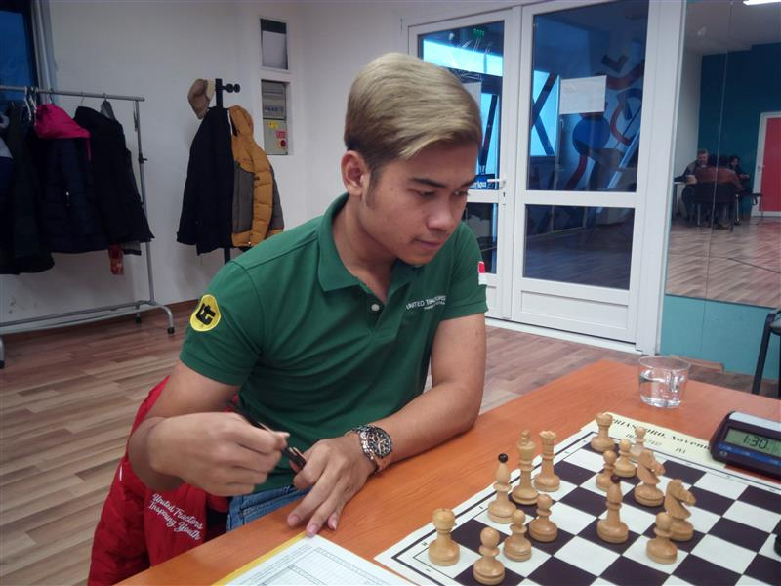
IM PRIASMORO, Novendra (INA, 2453) , his participation powered by the Untited Tractors company from his country…
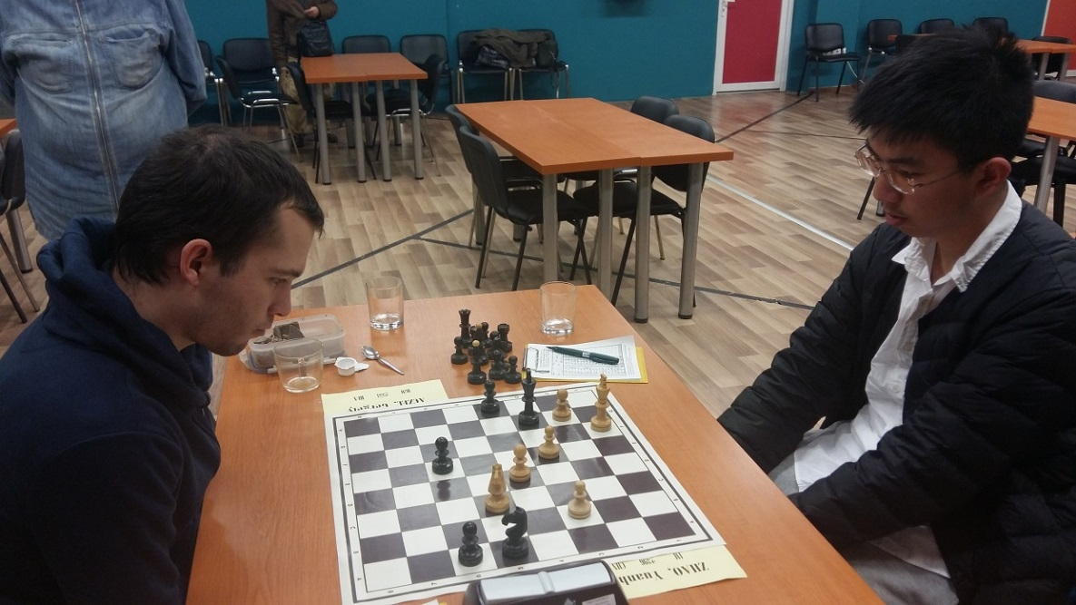
IGM ACZEL, Gergely (HUN) and FM ZHAO, Yuanhe (CHN)
Zhao reached his 3rd IM-norm.
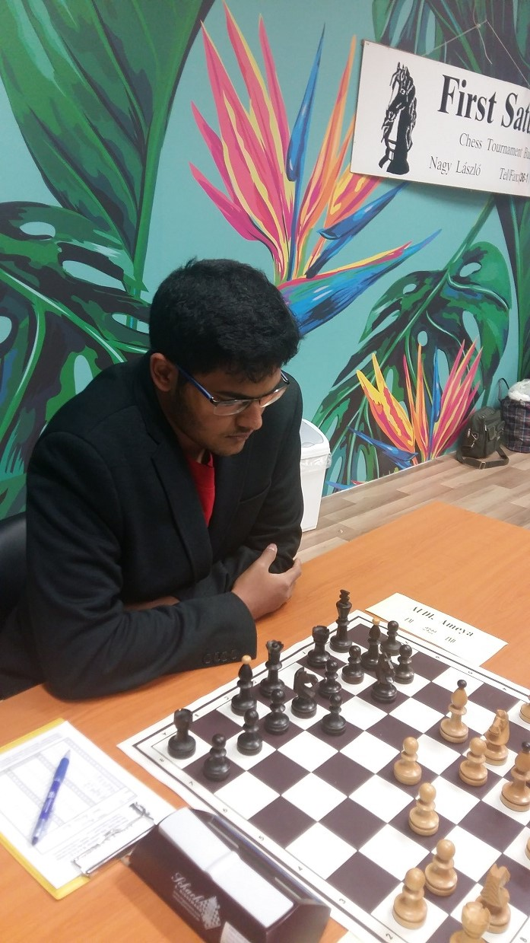
Geno Pharmaceuticals Brand Ambassador, FM AUDI Ameya (IND), who has been participating in
the First Saturday, Chess tournament since the past two years.

GM Final Ranking crosstable after 9 Rounds
Rk. |  |  | Name | Rtg | FED | 1 | 2 | 3 | 4 | 5 | 6 | 7 | 8 | 9 | 10 | Pts. | TB1 | TB2 | TB3
1 |  | IM | Priasmoro Novendra | 2452 | INA | * | 1 | ½ | 1 | ½ | ½ | 1 | 1 | ½ | 1 | 7,0 | 7,0 | 0,0 | 5
2 |  | GM | Aczel Gergely | 2553 | HUN | 0 | * | 0 | 1 | ½ | 1 | 1 | ½ | 1 | 1 | 6,0 | 6,0 | 0,0 | 5
3 |  |  | Zhao Yuanhe | 2396 | CHN | ½ | 1 | * | 0 | ½ | ½ | 1 | 0 | 1 | 1 | 5,5 | 5,5 | 0,0 | 4
4 |  | CM | Nguyen Van Thanh | 2353 | VIE | 0 | 0 | 1 | * | ½ | 1 | 0 | ½ | 1 | ½ | 4,5 | 4,5 | 1,5 | 3
5 |  | GM | Czebe Attila | 2392 | HUN | ½ | ½ | ½ | ½ | * | ½ | ½ | ½ | ½ | ½ | 4,5 | 4,5 | 1,0 | 0
6 |  | IM | Mihajlov Sebastian | 2357 | NOR | ½ | 0 | ½ | 0 | ½ | * | 1 | ½ | 1 | ½ | 4,5 | 4,5 | 0,5 | 2
7 |  | FM | Audi Ameya | 2322 | IND | 0 | 0 | 0 | 1 | ½ | 0 | * | 1 | 0 | 1 | 3,5 | 3,5 | 1,0 | 3
8 |  | FM | Orosz Andras | 2358 | HUN | 0 | ½ | 1 | ½ | ½ | ½ | 0 | * | ½ | 0 | 3,5 | 3,5 | 0,0 | 1
9 |  | GM | Chernyshov Konstantin | 2487 | RUS | ½ | 0 | 0 | 0 | ½ | 0 | 1 | ½ | * | ½ | 3,0 | 3,0 | 0,5 | 1
10 |  | GM | Farago Ivan | 2379 | HUN | 0 | 0 | 0 | ½ | ½ | ½ | 0 | 1 | ½ | * | 3,0 | 3,0 | 0,5 | 1

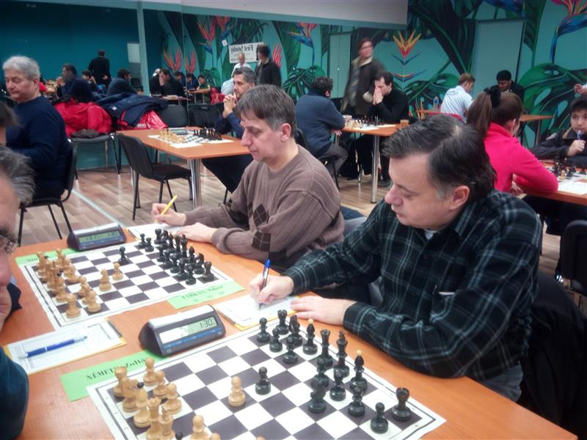
IGM ILINCIC, Zlatko (SRB, 2411) won the IM-section
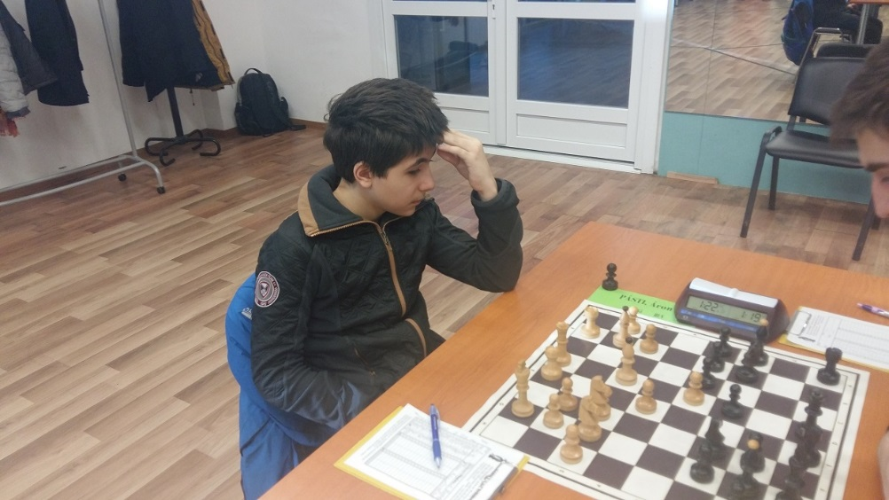
PÁSTI, Áron (HUN), 12 years

IM group final Ranking crosstable after 9 Rounds
Rk. |  |  | Name | Rtg | FED | 1 | 2 | 3 | 4 | 5 | 6 | 7 | 8 | 9 | 10 | Pts. | TB1 | TB2 | TB3
1 |  | GM | Ilincic Zlatko | 2411 | SRB | * | ½ | ½ | ½ | 1 | 1 | ½ | 1 | 1 | ½ | 6,5 | 6,5 | 0,0 | 27,25
2 |  | IM | Nemeth Zoltan | 2264 | HUN | ½ | * | ½ | 1 | ½ | 1 | 0 | 0 | 1 | 1 | 5,5 | 5,5 | 0,0 | 23,25
3 |  | WIM | Terbe Julianna | 2275 | HUN | ½ | ½ | * | ½ | 1 | ½ | 0 | ½ | ½ | 1 | 5,0 | 5,0 | 1,5 | 21,50
4 |  | IM | Farkas Tibor | 2317 | SRB | ½ | 0 | ½ | * | ½ | 1 | ½ | ½ | 1 | ½ | 5,0 | 5,0 | 1,0 | 21,00
5 |  | WIM | Dimitrova Aleksandra | 2242 | RUS | 0 | ½ | 0 | ½ | * | 1 | ½ | ½ | 1 | 1 | 5,0 | 5,0 | 0,5 | 19,25
6 |  | FM | Belous Mikhail | 2311 | UKR | 0 | 0 | ½ | 0 | 0 | * | 1 | 1 | 1 | 1 | 4,5 | 4,5 | 1,0 | 16,00
7 |  | CM | Pasti Aron | 2185 | HUN | ½ | 1 | 1 | ½ | ½ | 0 | * | ½ | ½ | 0 | 4,5 | 4,5 | 0,0 | 22,00
8 |  |  | Mihalik Agoston | 2206 | HUN | 0 | 1 | ½ | ½ | ½ | 0 | ½ | * | 0 | ½ | 3,5 | 3,5 | 0,0 | 16,50
9 |  | FM | Lyell Mark | 2333 | ENG | 0 | 0 | ½ | 0 | 0 | 0 | ½ | 1 | * | 1 | 3,0 | 3,0 | 0,0 | 10,75
10 |  |  | Leszko Bence | 2152 | HUN | ½ | 0 | 0 | ½ | 0 | 0 | 1 | ½ | 0 | * | 2,5 | 2,5 | 0,0 | 12,00

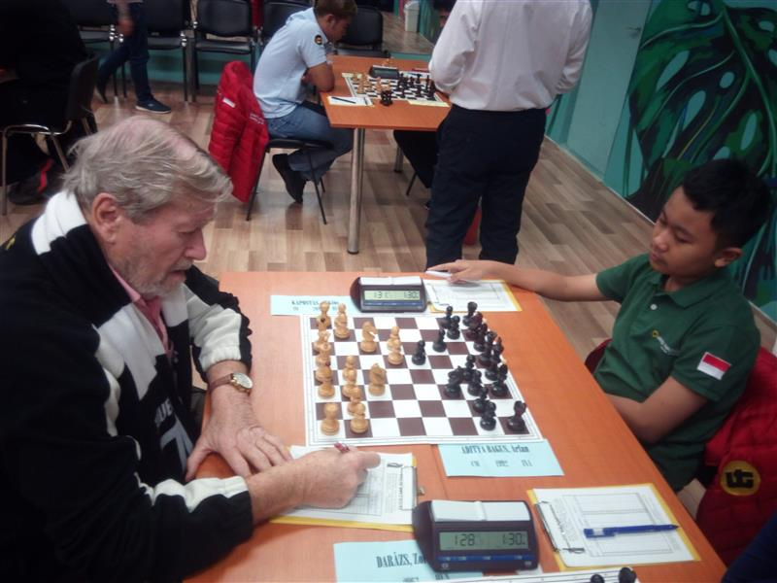
Left: Arfan Aditya Bagus (INA) – Right IM Kaposztas (HUN), 80 year old - Nadassy group

Female players in the First Saturday 2019 Febr.
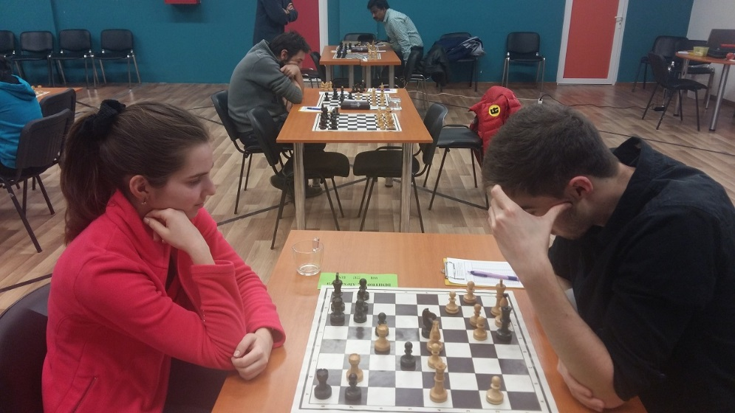
Left. WIM DIMITROVA, Alexandra (RUS). Her opponent collects the energy to resign…

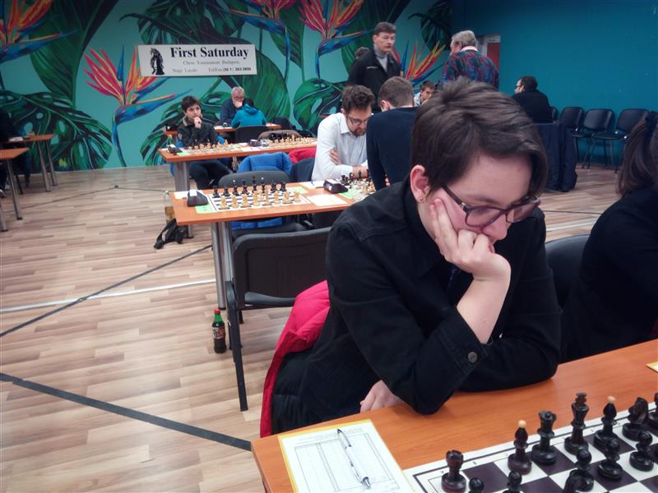
WIM Terbe Julianna (HUN, 2259)

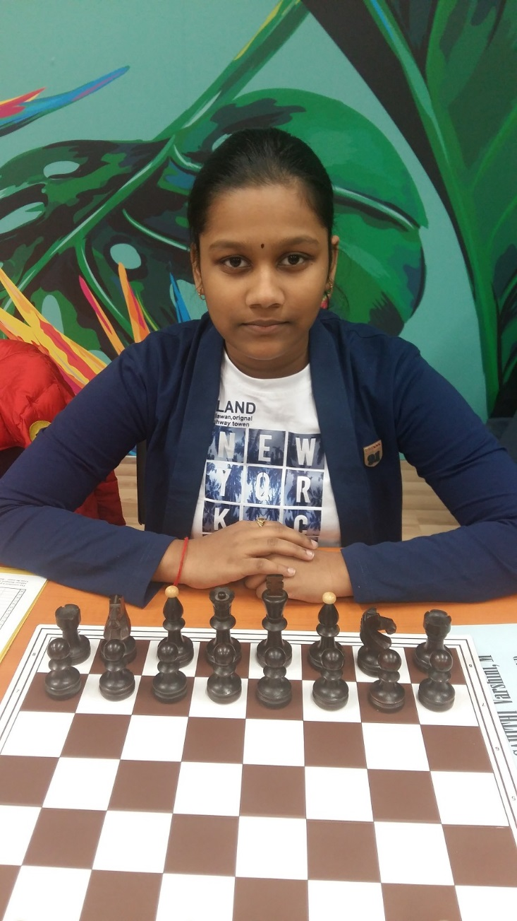
Sahithi Varshini Moogi (IND), Nadassy group

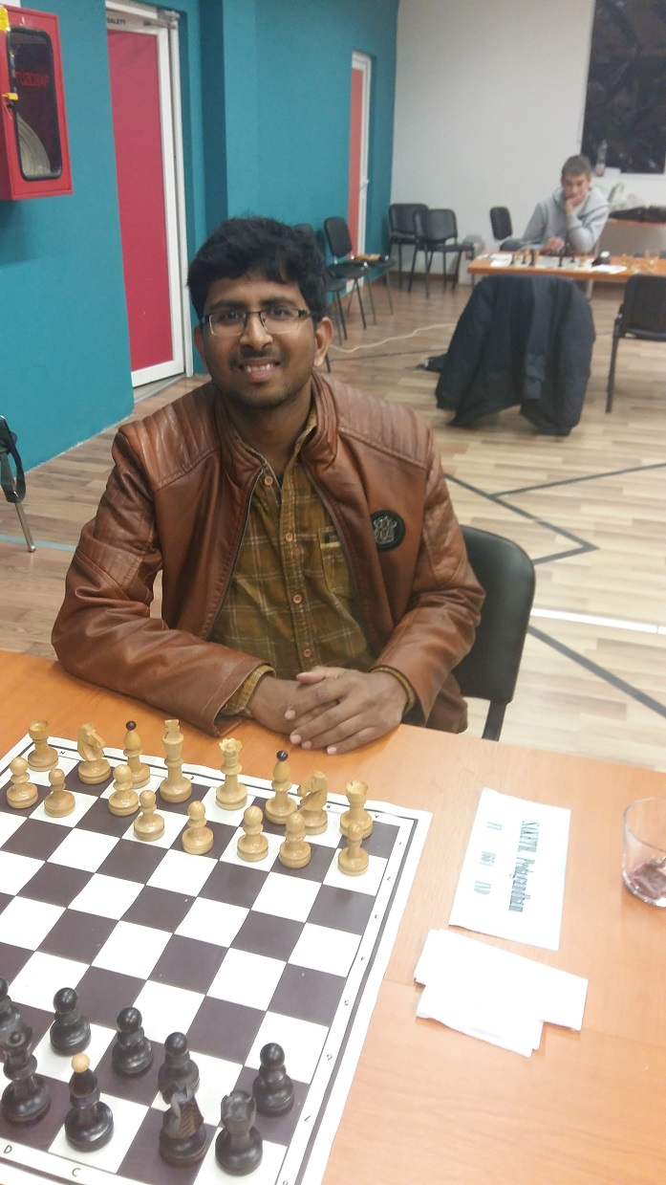
Mr SAKETH from India – Nadassy group
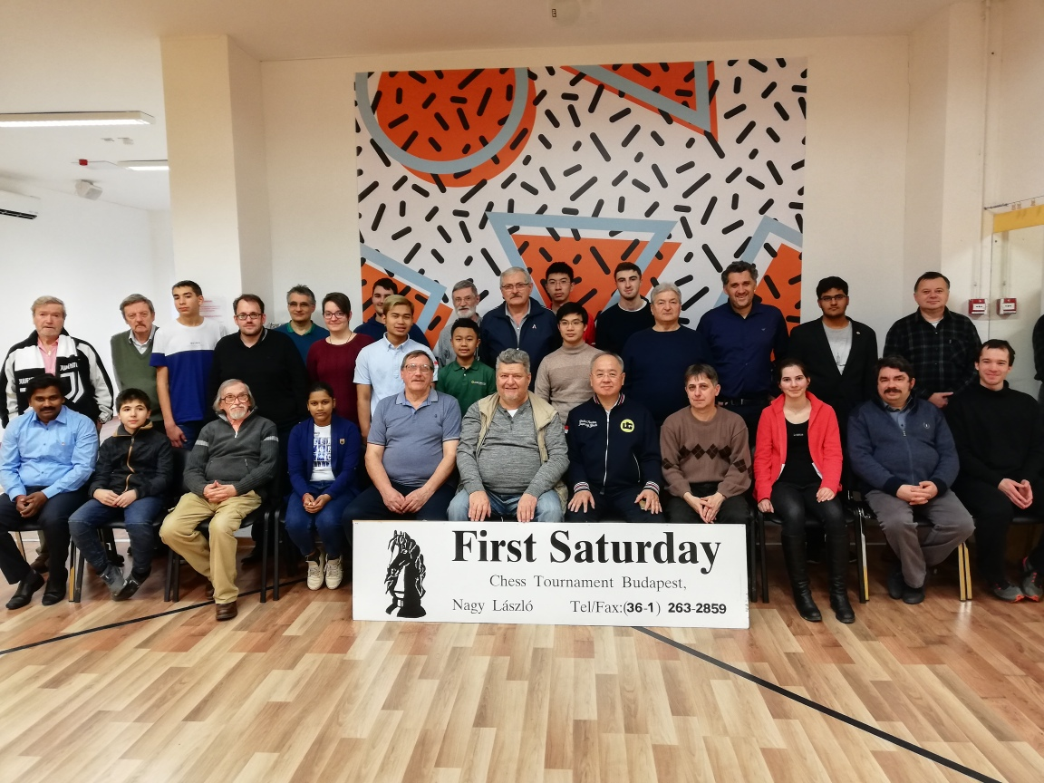
The traditional group photo, 2019 Febr.

Written by: IO Nagy Laszlo
www.firstsaturday.hu
Whatsapp: +36-30-230-1914

